 | CỘNG HÒA XÃ HỘI CHỦ NGHĨA VIỆT NAM  Độc lập – Tự do – Hạnh phúc
 | Tp. Hồ Chí Minh, ngày tháng năm 2021

ĐỀ CƯƠNG CHI TIẾT (DỰ KIẾN)

- Student’s name:
Vũ Nam Hải -ID: 17141006
Dương Công Trí -ID: 17141030
- Class: 17141CLA
- Major: Electronic & Telecommunication Engineering Technology
- Instructor: ThS. Nguyễn Thanh Nghĩa
- Project’s name: The design of system for distance registration in COVID-19 test based on IoT
Chapter 1: OVERVIEW
  - Introduction
Fourth Industrial Revolution is growing and widely used. People's lives are improving physically and mentally thanks to technological development. Especially, the development of technology opens the new application in the median fielded and widely used. Under the duration of the outbreak of the Covid 19 pandemic, many new technology applications have been developed and applied. Online service for buying food, necessities, or medicine rapidly grows. On the other hand, most invent are contribute to the medical field because nothing is more important than control Covid 19 pandemic at this time.

One of the biggest problems in the processing of control Covid 19 pandemic is organized take sample Covid test activity. This activity must be done in every local of the epidemic area. The limit of the number of doctors and nurses along with the many tasks that must be done leads to many issues. The rally of a large group of people that require to take a sample test might be a potential of unknown infectious. For instance, people usually try sharing a pen to fill in the information forms. Moreover, doctors always have a hard time try to make a sort list because everybody wants to be the soonest person to take the sample test as possible. That is why a new product or method need to build and applied to reduce the unknown infectious along with tasks for doctors and nurse.

The application of IoT technology has become more and more popular. The “The IoT for Healthcare Applications” article by Hadeel Kareem Hassan, Jameel Kaduim Abed, and Muthana Arzuqi Waheb [1] shows that the combination of the features of the IoT in medical devices contributed greatly to improving the quality and effectiveness of medical services. “A Study of Internet of Things enabled healthcare acceptance in Malaysia” by Yap Sy Yuan, Dr. Tan Chye Cheah [2] also shows that the aim of IoT enabled healthcare is to eventually provide low-cost, advanced technology, and high accessibility care services for patients and consumers. Many applications of IoT have become the key to the development of the medical field.

For these reasons mentioned above, the group we have proposed the project: “The design of system for distance registration in COVID-19 test based on IoT”. This system will constrain the contact between people and increase the effect of receiving data from users who need to take samples.

  - Purpose:
The purpose of this project is to build a model to reduce the difficulty in signing paper and limit the interaction between people. The model is able to gather the data from the application which is given by people who want to travel. The model uses ESP32 as a microcontroller and Wi-Fi, Bluetooth connection in order to transfer data from the application and website.

  - Object and Scope of the Study:
Object of the study is to successes automatic the process of gathering COVID-19 test papers and delivering the information to doctor. The Scope of the study is applied automation to reduce the inconvenience of users.

  - Research Methodology:
The research method of the report will be based on the design of a model for the product. The effectiveness of the product will be compared when applied in practice with the traditional method of collecting test sheets. Compare the ability to store data and update data after completing the testing process to patients or people at risk of infection.

  - Outline: 1. Introduction, 2. Background, 3. Design of system, 4. Implement and Results, 5. Conclusion, 6. Future Scope

Chapter 2: BACKGROUND
- ESP32
The microprocessor used is the ESP32 NodeMCU-32 V1.2 WiFi BLE RF Transceiver Kit. With the central module, ESP32, which integrates Wi-Fi and BLE technologies, the processor is suitable for building compact IoT devices.

Hardware features:
- Producer: Ai-Thinker
- Center Module: Ai-Thinker ESP32-S
- SPI Flash: 32Mbits
- Frequency Range: 2400~2483.5Mhz
- Bluetooth: BLE 4.2 BR/EDR
- WiFi: 802.11 b/g/n/e/i
- Support Interface: UART/SPI/SDIO/I2C/PWM/I2S/IR/ADC/DAC
- Source: 5VDC from Micro USB.
- Size: 25.4 x 48.3mm
- A-MPDU & A-MSDU aggregation & 0.4µs guard interval

- LCD
LCD screen to provide some necessary information for doctors and testers in the area: name of person in turn to take samples, connection status to the device's web server.

Hardware feature:
- Operating voltage: 5VDC
- IC Driver: ST7920
- Black and green background text
- Graphic LCD: 128×64 pixels
- Communication standard: Serial, 4-bit parallel, 8-bit parallel
- Dimensions: 93 x 70 x 13.5 mm - Screen size: 77 x 50 mm

CHAPTER3: DESIGN OF SYSTEM

- Content 1: Back ground
- Content 2: Design of Flow chart, schematic diagram
- Content 3: Connect ESP32, LCD
- Content 4: Build program for Arduino Uno
- Content 5: Test run, evaluate, adjust
- Content 6: Interface design
- Content 7: Writing Report
- Content 8: Presentation

CHAPTER 4: IMPLEMENT AND RESULTS
- Block Diagram:
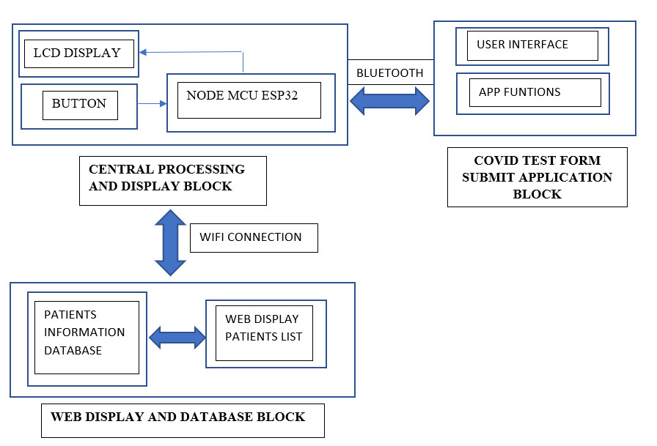

CHAPTER 5: CONCLUSION
CHAPTER 6: FUTURE SCOPE

REFERENCE
[1] Hadeel Kareem Hassan, Jameel Kaduim Abed, Muthana Arzuqi Waheb, “The IoT for Healthcare Applications”, Department of Medical Instrumentation Techniques Engineering, Middle Technical University, 2021
[2] Yap Sy Yuan, Dr. Tan Chye Cheah, “A study of Internet of Things of enabled healthcare acceptance in Malaysia”, School of Computing, Asia Paciffic University of Technology & Innovation, 2020
APPENDIX

